SevaOne - Service Plus
Token-Based Integration with Departments
Plug-and-play design on WSO2 Identity Server and API Manager
Draft for discussion · 19 October 2026

1. High-Level Design (Web)
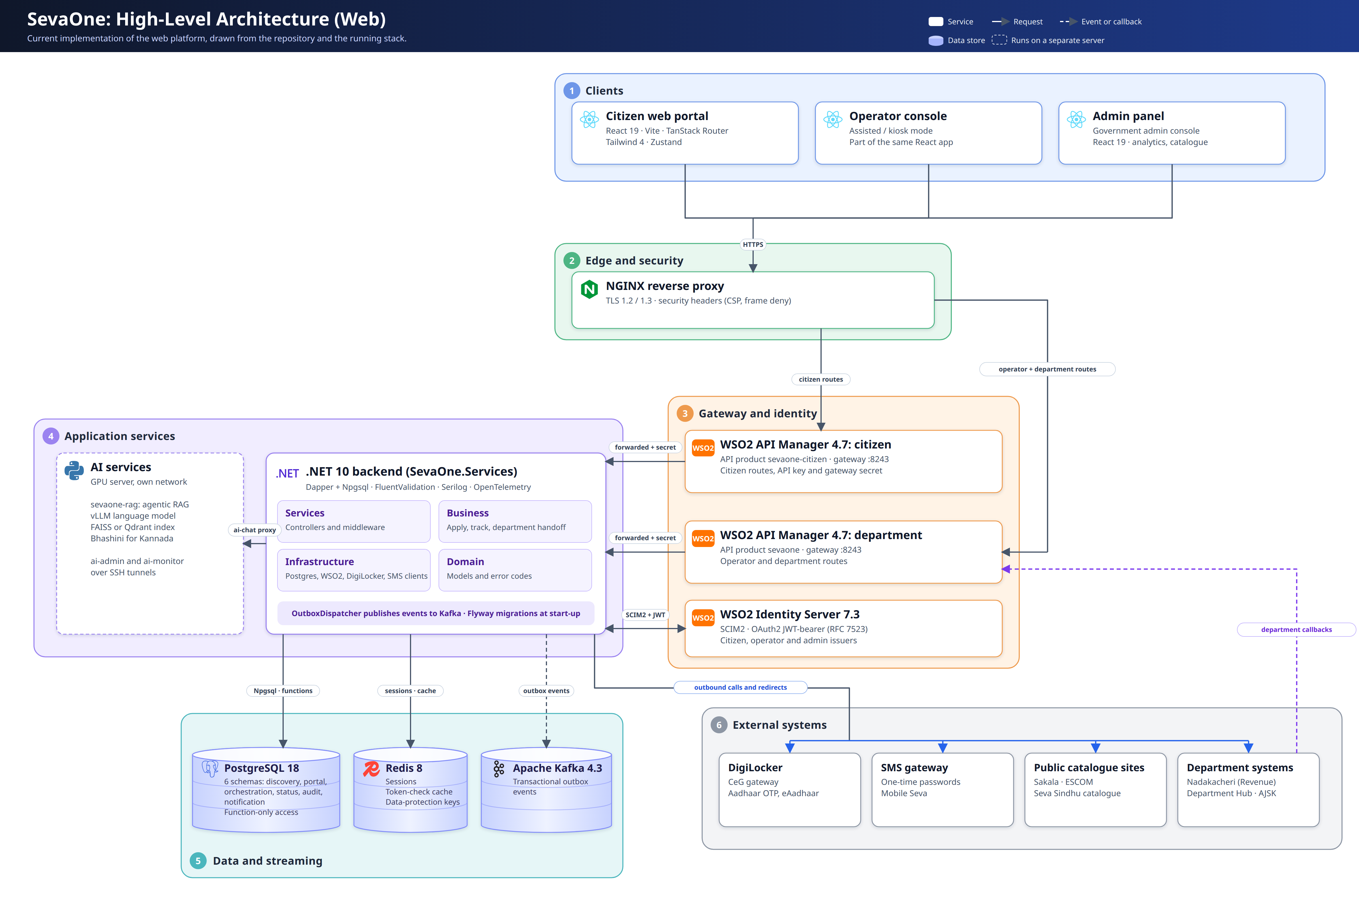

1.1 Features Implemented in the Codebase Today
Area | What is working
Citizen sign-in | Mobile OTP and DigiLocker (Aadhaar). WSO2 Identity Server session. Sessions kept in Redis.
Service catalogue | Departments, sub-departments and services, filtered by user type. Search. Live notices per service.
Apply and track | Apply to a department service, return from the department, application tracking and timeline.
Assisted mode (operator) | Operator login, apply on behalf of a citizen, citizen OTP binding.
Department integration | Five endpoints under /api/v1/dept, protected by WSO2 API Manager and Identity Server.
Other redirect methods | AJSK and Sakala (including ESCOM) token redirects, chosen per service.
Admin panel | Overview, catalogue, departments, districts, citizens, operators, funnel, aging, Sakala SLA, notices, notifications, activity log, AI operations, admin management.
AI assistant | Chat for finding services, on the GPU server (separate), reached through the backend.
Platform | Kafka outbox events, Redis cache, PostgreSQL with 6 schemas, Flyway migrations, health checks, stable SEVA-* error codes.

2. Department Integration [Currently Implemented]

2.1 Architecture
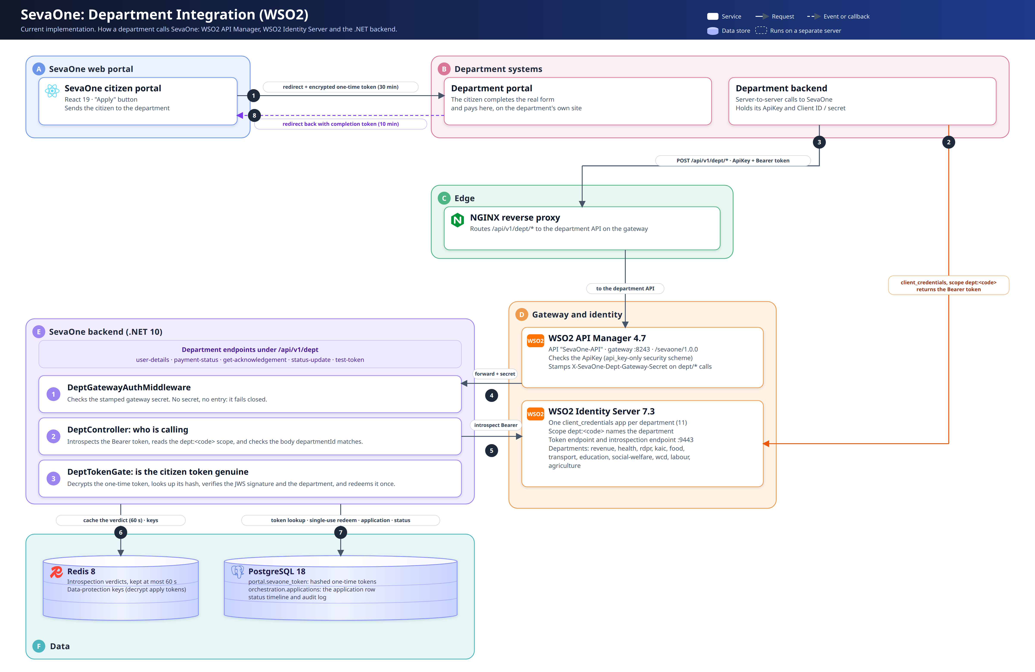

2. Department Integration [Currently Implemented]

2.2 Sequence of Calls
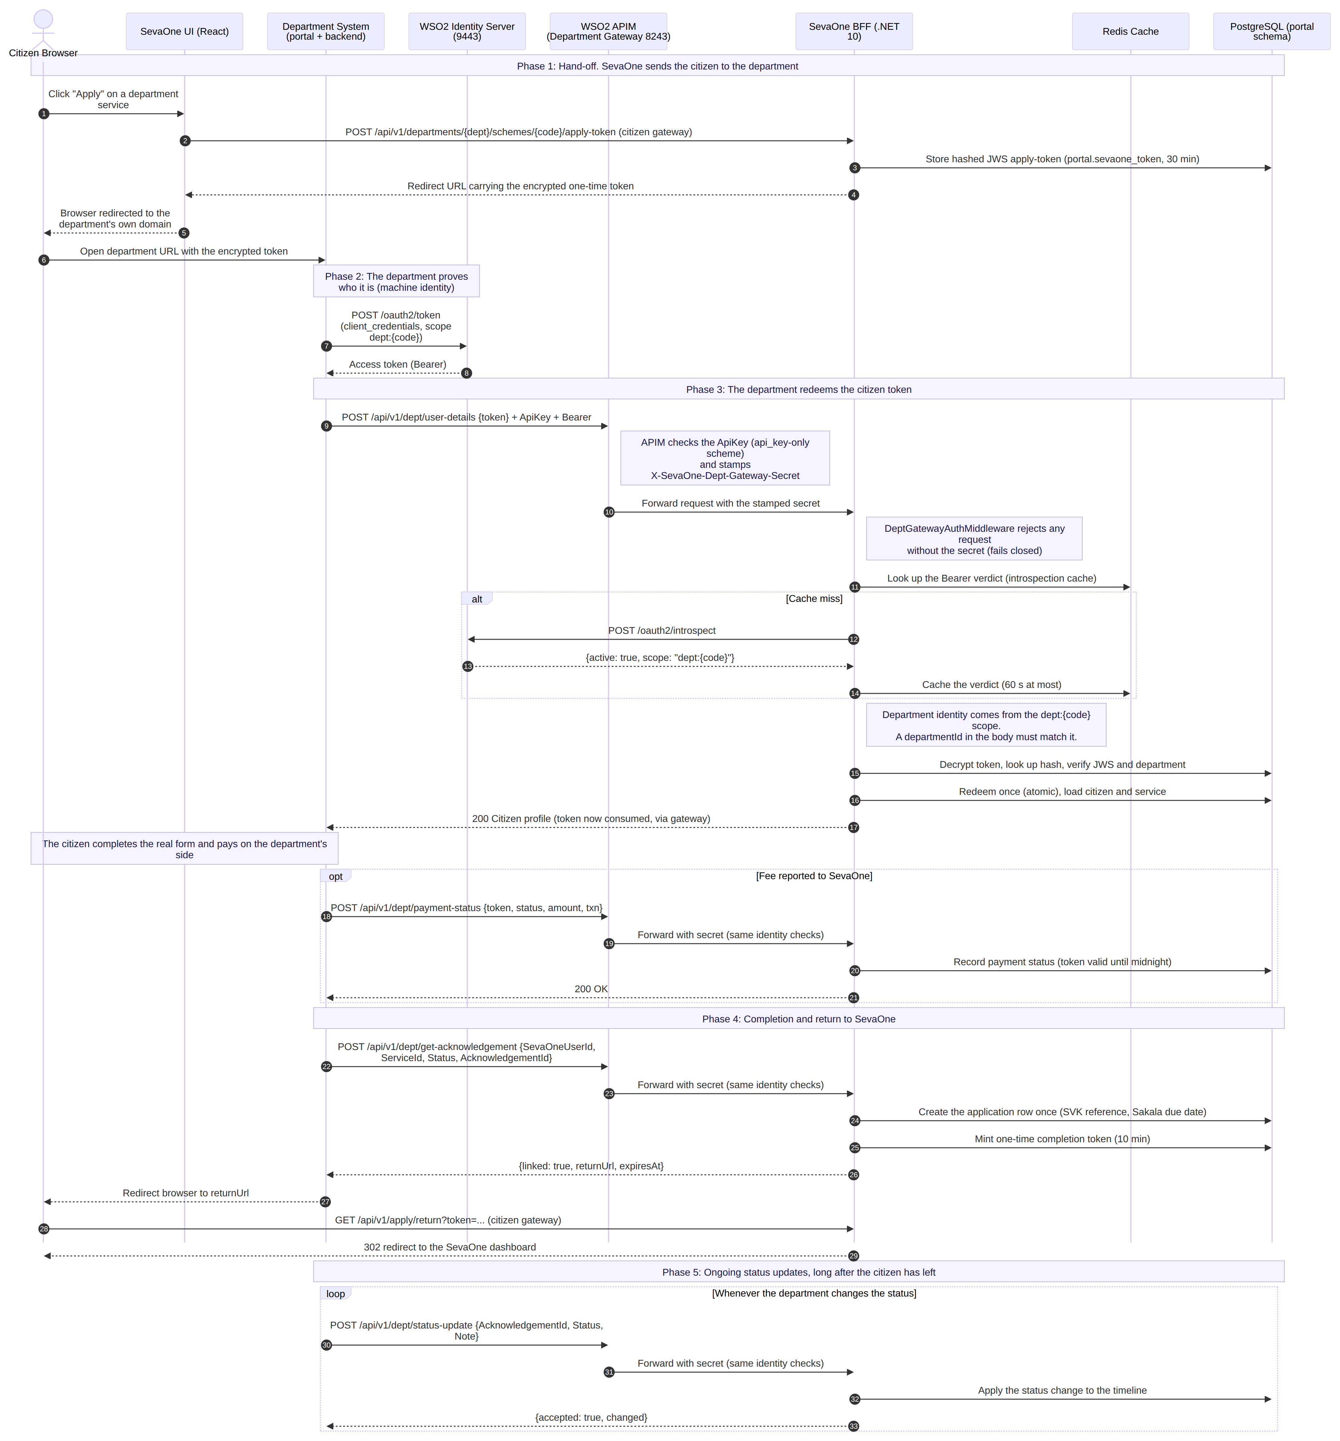

2. Department Integration [Currently Implemented]

2.3 How It Works
- The citizen clicks Apply. SevaOne creates a one-time, encrypted token and sends the citizen to the department.
- The department gets its own identity from WSO2 Identity Server (one account per department).
- The department calls SevaOne through WSO2 API Manager with its ApiKey and Bearer token.
- SevaOne checks the gateway secret, the department identity and the citizen token, then redeems the token once.
- When the citizen finishes, the department calls get-acknowledgement. SevaOne creates the application and sends the citizen back.
- The department pushes status updates whenever the status changes.

WSO2 is used for
- API Manager: ApiKey check and the gateway secret on every department call.
- Identity Server: one identity per department, checked on every call, and disabled instantly if needed.

3. Department Integration [Plug and Play]

3.1 Architecture
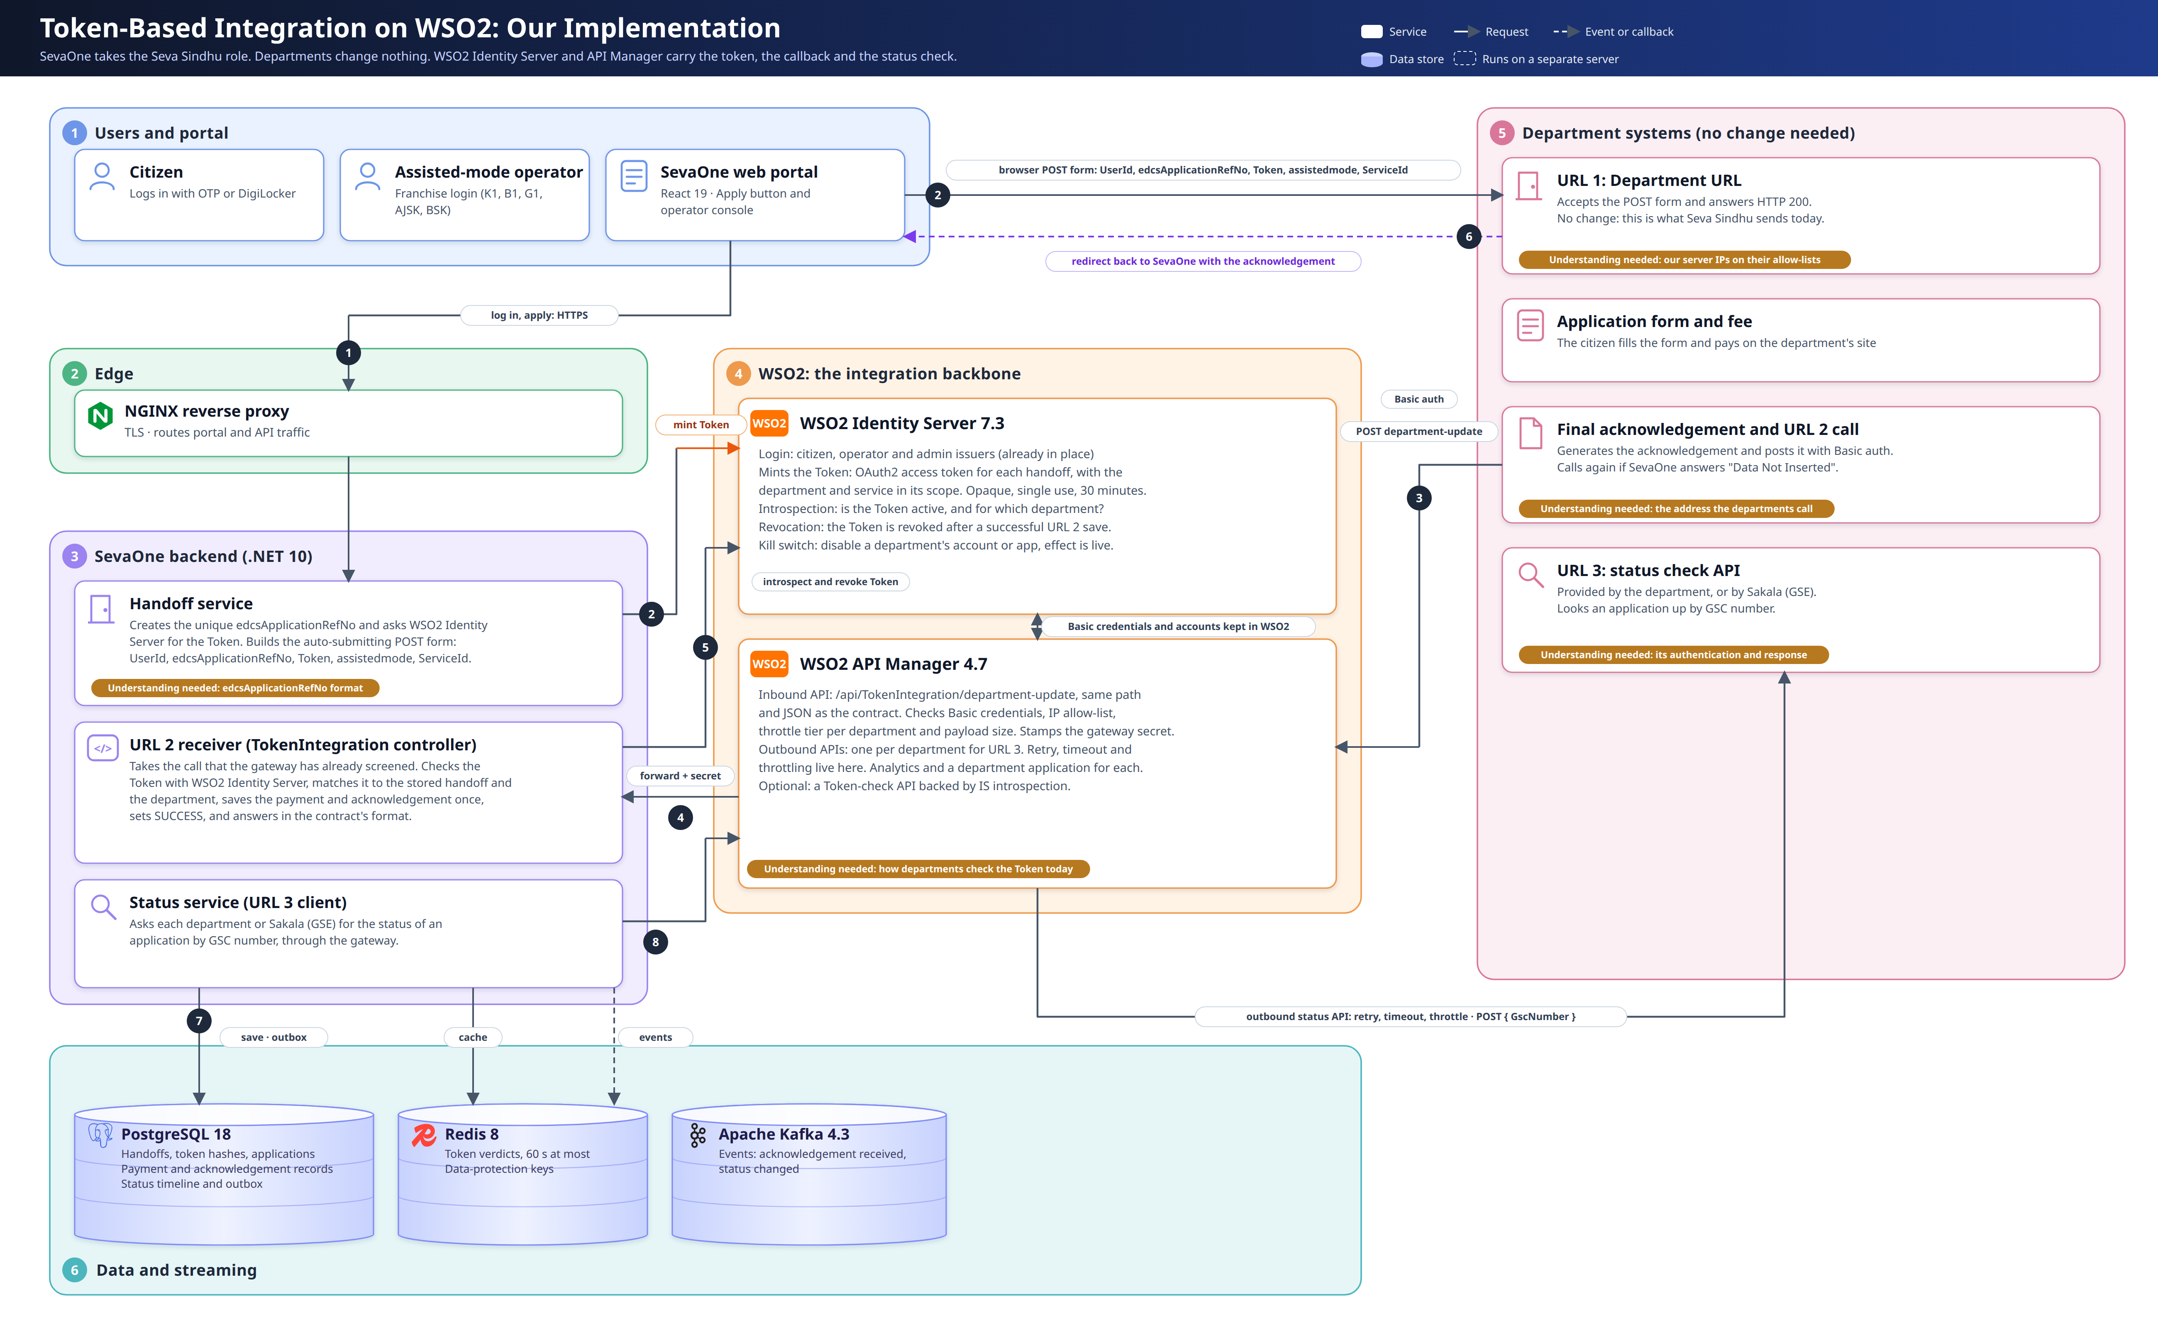

3. Department Integration [Plug and Play]

3.2 Sequence of Calls
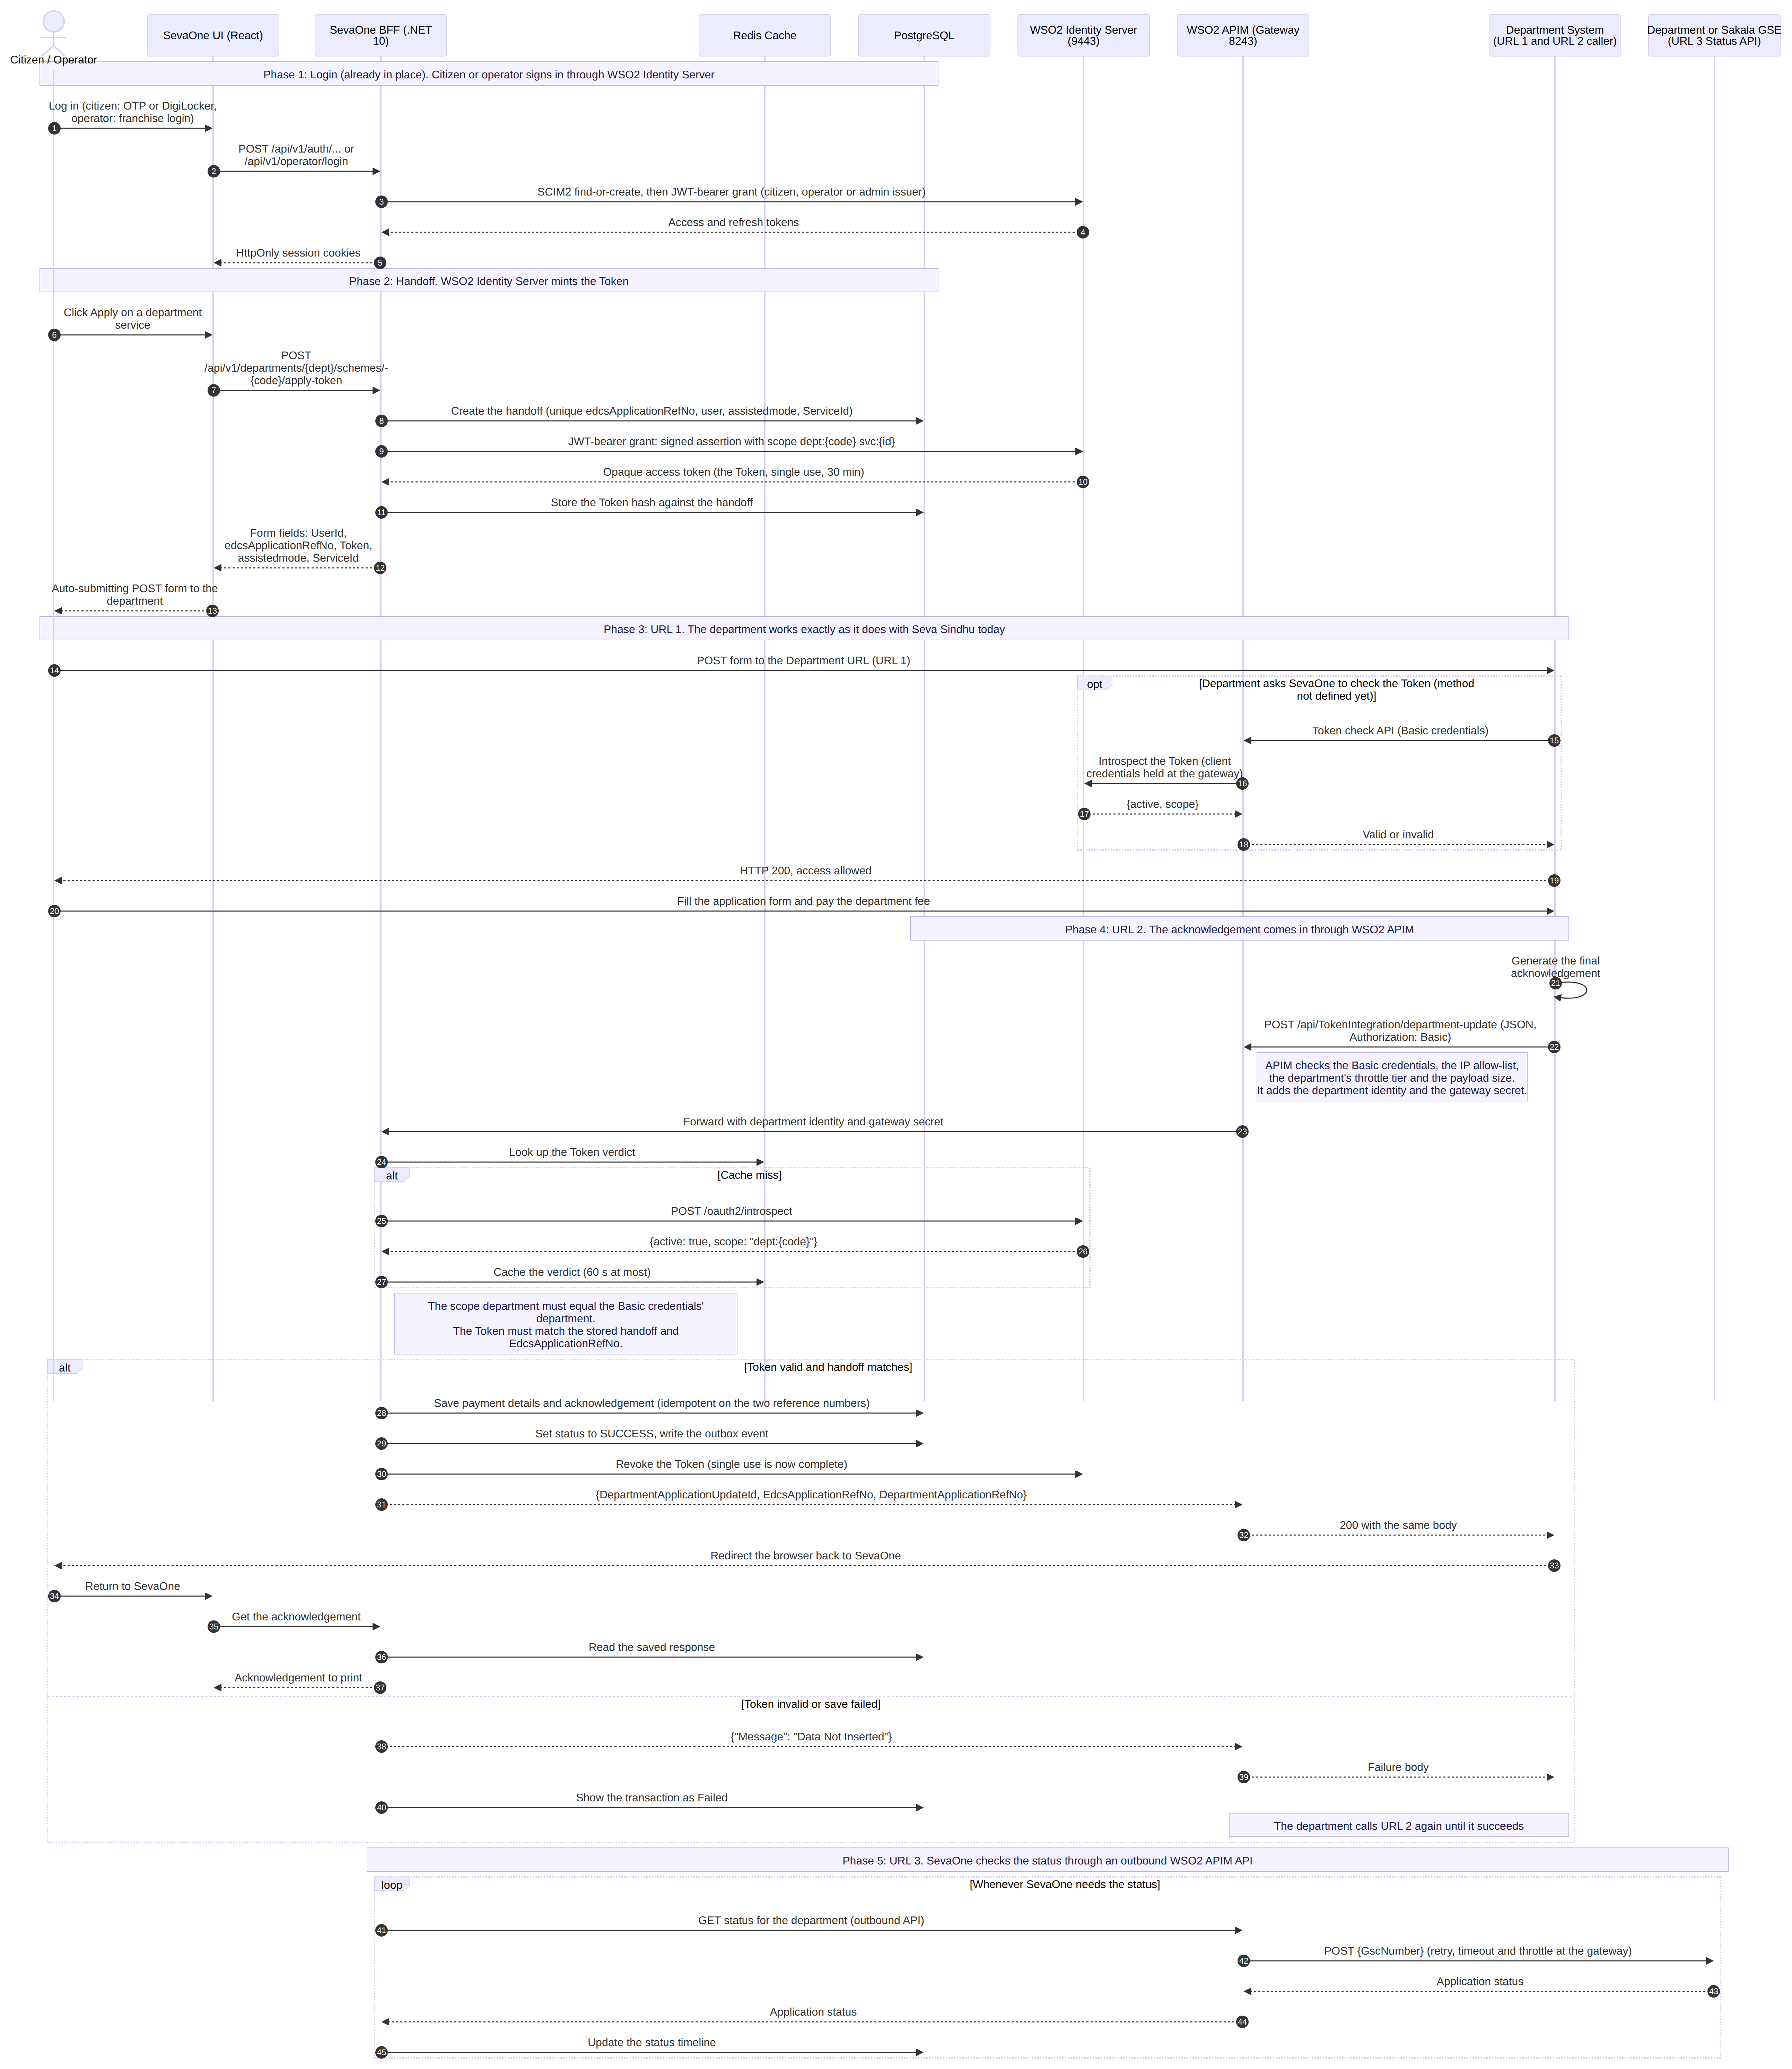

3. Department Integration [Plug and Play]

3.3 How It Works
- The citizen clicks Apply. SevaOne creates a handoff and asks WSO2 Identity Server for a Token.
- SevaOne sends the browser to the department with a POST form: UserId, edcsApplicationRefNo, Token, assistedmode, ServiceId.
- The department works exactly as it does with Seva Sindhu today. No change for the department.
- The department posts the final acknowledgement to one URL. WSO2 API Manager checks the credentials, IP and limits.
- SevaOne checks the Token with Identity Server, saves the acknowledgement once, sets SUCCESS and revokes the Token.
- SevaOne asks the department for status using the GSC number, through an API Manager outbound API.

WSO2 is used for
- Identity Server: creates, checks and revokes the Token. Holds the department accounts.
- API Manager: publishes the acknowledgement URL, checks credentials, IP and limits, and carries the status calls with retry.

Still to confirm
- The address departments call for the acknowledgement, and the IP allow-lists on both sides.

4. Drawbacks of Plug and Play: What We Give Up
What we lose | The advantage we had today
Per-department identity | Each department has its own WSO2 identity that can be disabled instantly. The contract uses one shared Basic credential.
Status pushed to us | Departments tell us when a status changes. In the contract we must ask, call by call.
Clear error codes | Departments get a specific code for each problem. The contract returns only "Data Not Inserted".
A handoff that stands alone | Starting an application does not need Identity Server today. In the new way, every handoff does.
A contract we control | We can change our own contract. The new one belongs to Seva Sindhu and has open points.
Less gateway work | No extra inbound API, throttle tier or outbound API for each department.

5. Future: Coming Back to the Original Architecture

How to come back
- One core. Handoff, application record, status and events are the same for both contracts.
- A switch per service. The integration-method setting on each service picks the contract. No release needed.
- Keep the current endpoints. Nothing is removed; plug and play is added beside them.
- Move department by department. Finish applications in progress on their own contract, then switch the service.
- Finally unpublish the acknowledgement API and the outbound status APIs.

What we gain by coming back
- Our own contract, which we can version.
- Stronger department identity, revocable instantly.
- Status pushed to us, with clear error codes.
- Less to configure and support in WSO2.

